**Safety Gadget for Child Safety**

**Monitoring and**

**Notification**

***Category*:** Internet of things

***Industry Mentors :-***

* Sowjanya
* Sandeep

***Faculty Mentor:-***

G.Monisha

***Team Leader:-***

JV.Jayslin Varsha

***Team Member:-***

* P.Jenitta Deva Sujil
* S.Josline Christina
* A.Iswariya

***Use cases:-***

* Safety gadget for child safety monitoring and notification

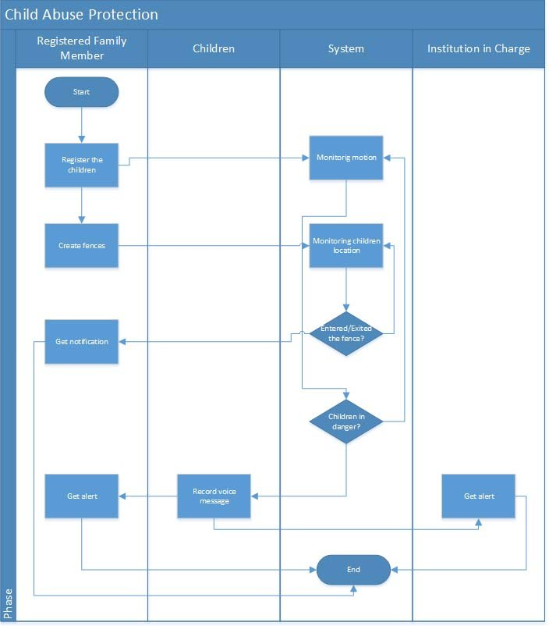

* The overall percentage of child abusements filed nowadays in the world is about 80%, out of which 74% are girl children and the rest are boys. For every 40 seconds, a child goes missing in this world. Children are the backbone of one’s nation, if the future of children was affected, it would impact the entire growth of that nation.

***Novelty:-***

* The major goal of this project is to use modern technology to create a gadget that provides "Smart Child Safety" to protect children, which will be far more effective than current methods in assisting victims.
* This device is used to alert the parents.In the event of a power outage, the wearable serves as a backup. On the device, there is an additional panic button.
* The purpose of this button is to notify parents and the police of a child's current location whenever they are in a perilous scene.

***Feasibility of ideas:-***

* A feasibility of idea contains a detailed analysis of what's needed to complete the proposed project.
* The report may include a description of the new product or venture, a market analysis, the technology and labor needed, as well as the sources of financing and capital***.***
* Create a strong unique brand.
* Have a business plan.
* Know your unique selling points and capitalise on them.

***Business model:-***

* The paid app business model simply means your app is not free to download.
* We can focus on Exporters in Exporting countries generate revenue by selling our application.
* A business model describes how an organization creates, delivers, and captures value.
* In economic, social, cultural or other contexts. The process of business model construction and modification is also called business model innovation and forms a part of business strategy.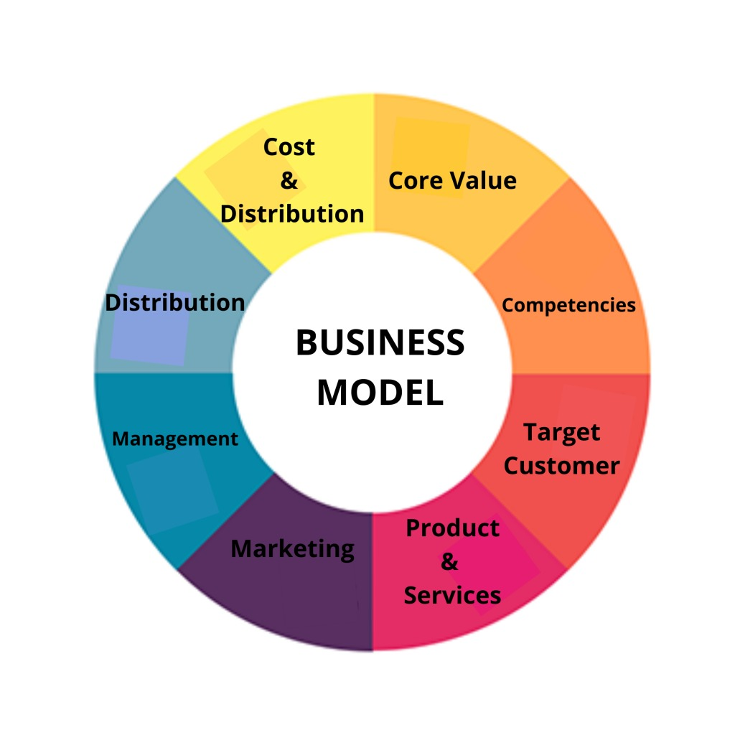

***Social impact:-***

* The most important reason for monitoring each child's development is to determine whether a child's development is on track.
* Looking for developmental milestone is important to understanding each child development and behaviour.
* Milestone can help explain a child behaviour.
* The child safety wearable device can act as a smart device.
* It provides parents with the real-time location, surrounding temperature, SOS light along with Distress alarm buzzer for their child's surroundings and the ability to locate their child or alert bystanders in acting to rescue or comfort the child.

***Scalability of solution:-***

* This allows parents to keep a track of their child's location and also, help them raise an alarm in case of an emergency.
* This device, which can be carried in pocket, strapped to body or worn around the neck, allows the parents to create safe zones for their child, including school, home, parks or even tuition centres.
* The main goal of this project is to create a smart wearable device for children that use advanced technology to ensure their safety.
* As a result, this strategy is perceived as sending an SMS from the children\'s wearable to their parents or guardians.
* This project employs cutting-edge technology to protect the youngster through the use of a GSM module, ensuring that the child does not feel abandoned while dealing with such social issues.
* An Arduino Nano, GSM, GPS, temperature sensor, heartbeat sensor, and a panic button will be included in the wearable.
* The heartbeat sensor detects the child\'s heart rate and delivers it to the guardian on a regular basis. If the child falls suddenly, the accelerometer detects it and alerts the parents. As a result, the parent has a sense of security.